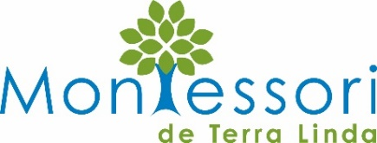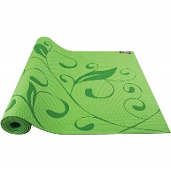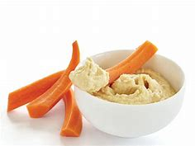
Lower Elementary Yoga & Cooking Spring Camp
This program will be open to all Lower Elementary students. During this camp, led by Cyrelle, a Certified Ayurvedic Yoga teacher and Certified Natural Foods Chef who has worked in local Schools since 2009. This camp will teach kids about the healing, calming benefits of yoga and meditation, along with connecting more deeply into our bodies. We will incorporate games and mindfulness throughout the day. This camp is a perfect way to build deeper friendships and learn about team building! We will end each day with a delicious, nutritious, vegetarian lunch. The kids will help prep the meals, as they learn about wholesome recipes and organic, gluten free/ nut free ingredients.
………………………………………………………………………………………………………………………………………………
Lower Elementary Spring Yoga and Cooking Camp is held from 9am – 12pm
April 8 - August 12, 2019: $55/ day, $260 week
We welcome students to enroll who are current MdTL
Lower Elementary students.

Minimum of 6 students, maximum enrollment is 14 students
Drop-ins by the day dependent upon space availability.
Please submit registration and payment by check made payable to MdTL or register via Sign Up Genius.
All fees are final and are not refundable due to absence or
withdrawal after Friday, March 15, 2019.

Number of days ______ x $55
or Weekly Rate ($260) _________
= total fees ______________

- April 8th
- April 9th
- April 10th
- April 11th
- April 12th

Student’s Name: ____________________ Parent's Signature __________________________

