MdTL presents our After School Program

Circuitry
with
Ms. Obata

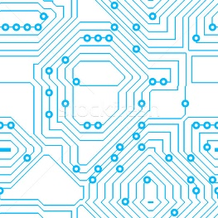

6 Weeks

Students will design and create light-up projects with conductive thread and LED lights. The lights help them discover how simple and parallel circuits work. They'll start out making their own light-up flickering patch and end by designing and sewing their own light-up parallel circuits.

About the teacher: Barbara Obata has worked as an adjunct professor at the College of Marin and has a background in web development, web security systems, graphics production, and technical product management. She has worked for Charles Schwab, and UCSF, among other organizations, and has led a number of Maker workshops and also conducts woodshop, sewing and soft circuitry workshops for the Girl Scouts of America.

Session II ~ Thursdays
Art Room
Oct 27, Nov 3, 10, 17, Dec 1, 8
3:10 – 4:10 PM
Ages 9-12
(Upper Elementary)
- Classes must have a minimum of 6 children with a maximum of 12 children
- Classes are $200 per child (includes materials fee) / 6 weeks
- First come, first served for space within the class

Please return portion below with payment to the front office

Elementary Circuitry ~ Session II Please make checks payable to MdTL

Child’s Name _________________________________ Parent's Name________________________________

Phone Number _______________________________ Birthday/Age _________________________________

Food Allergies/Sensitivities __________________________________________________________________

Montessori de Terra Linda ● 610 Del Ganado Road ● San Rafael, CA 94903 ● 415.479.7373 ● www.mdtl.org

